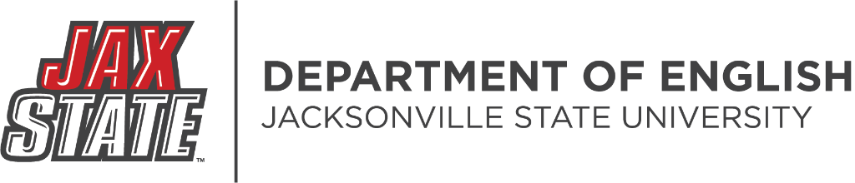

EH 142.000 Honors Speech: Course Policies and Syllabus
Scheduled Meeting Days and Times
Classroom

…
Course Description: (3) Advanced instruction in the foundations of effective public, interpersonal, and professional communication. Focuses on developing sophisticated speech organization, delivery, and audience engagement; includes instruction in multimodal presentations, interviewing, virtual meetings, and collaboration, as well as the importance of cultural norms, among other topics relevant to all academic and professional settings.

Course Objectives:
Students will give six effective major presentations in a variety of modes and using a variety of digital skills and visual aids. Students will practice advanced verbal and nonverbal communication in public, interpersonal, and professional settings, applying ethical and inclusive principles.

Student Learning Outcomes:
Upon successful completion of this course, students will be able to:
- Practice advanced principles of effective public, interpersonal, and professional communication.
- Implement ethical, inclusive communication practices by developing critical thinking, researching, and listening skills.
- Apply digital communication skills through h multiple media.
- Craft and present an effective multimodal presentation.
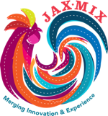
- Produce a professional resume, job letter, and interview.
- This course includes the Jax MIX student learning outcome of Written communication/ Oral communication: As effective communicators, students will be able to generate ethical communications that have a clear purpose, intended audience, and are well-organized according to disciplinary conventions

