UNIVERSITY POLICY:
All email signatures should consist of the following information and should not include any patterned backgrounds, photographic files, QR codes, personal logos, personal or departmental websites, or quotes.
*Please remember that the university-wide goal is to increase enrollment and brand the university.

Please do not change the font style or resize the font (Arial, size 12).
Please do not resize the logo.
Please do not change the colors.

You may remove any phone or fax number if not applicable.
You may add university related social media icons with hyperlinks.

If you choose the extended version and you have an off-campus address, that is acceptable.

"The Friendliest Campus in the South" is the university marketing campaign. Please do not remove.

For more information on university policies, standards, and guidelines, visit www.jsu.edu/marketingservices/styleguide.

Directions:
- Copy and paste your option into the email signature box.
- Optional: Download the Jax State email signature logo here:
www.jsu.edu/marketingservices/templates/images/jsu-email-logo.jpg
- Optional: Download the Jax State social media email icons here:
www.jsu.edu/marketingservices/templates/images/jsu-email-facebook.jpg
www.jsu.edu/marketingservices/templates/images/jsu-email-twitter.jpg
www.jsu.edu/marketingservices/templates/images/jsu-email-youtube.jpg
www.jsu.edu/marketingservices/templates/images/jsu-email-instagram.jpg

Examples:

EMAIL TEMPLATES ARE LISTED BELOW.

STANDARD VERSION:
(P: Phone, F: Fax, C: Cell, WC: Work Cell —You may remove any number not applicable.)

Name
Title
Office/Department Name/College Name
Jacksonville State University
P. XXX.XXX.XXXX | F. XXX.XXX.XXXX
C. XXX.XXX.XXXX | WC. XXX.XXX.XXXX
The Friendliest Campus in the South.
WWW.JSU.EDU

(Optional: PLACE JSU LOGO HERE-Please leave space between signature and logo)
(Optional: Social media information-MUST BE UNIVERSITY RELATED)
EXTENDED VERSION:
(P: Phone, F: Fax, C: Cell, WC: Work Cell—You may remove any number not applicable.)

Name
Title
Office/Department Name/College Name
Jacksonville State University
P. XXX.XXX.XXXX | F. XXX.XXX.XXXX
C. XXX.XXX.XXXX | WC. XXX.XXX.XXXX
Building Name & Office Number
700 Pelham Road North | Jacksonville, AL 36265
The Friendliest Campus in the South.
WWW.JSU.EDU

(Optional: PLACE JSU LOGO HERE-Please leave space between signature and logo)
(Optional: Social media information-MUST BE UNIVERSITY RELATED)

How to insert social media icons with hyperlinks:

Step 1. Click the first icon on the tool bar (insert pictures inline)-this will allow you to choose from your icons that you downloaded.

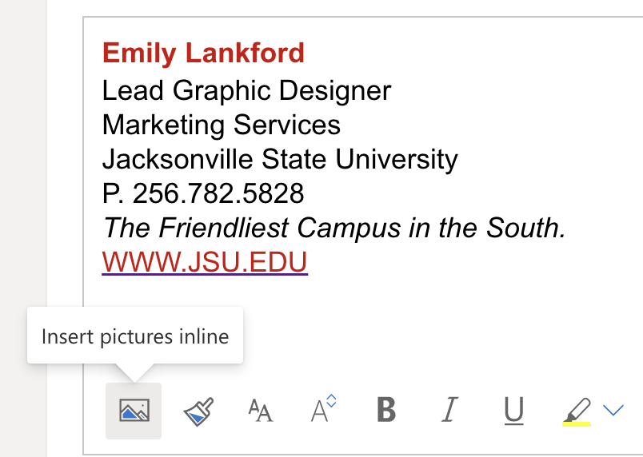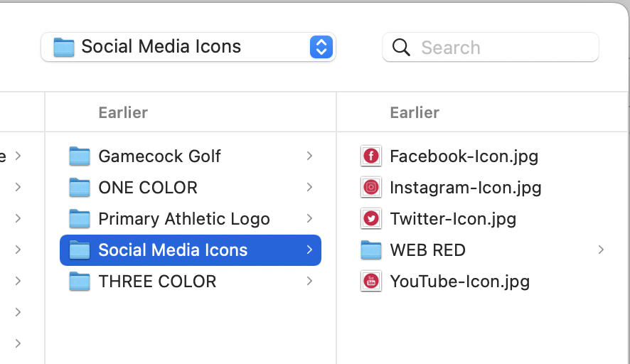

Step 2. Select the icon so that it is highlighted, and click “Insert link” on the
tool bar, then type in the URL.

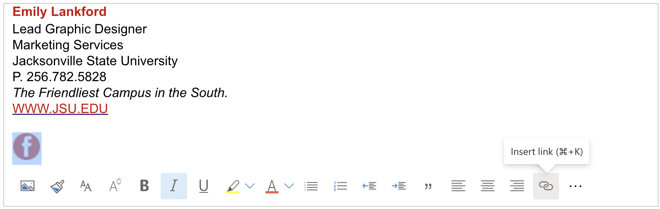
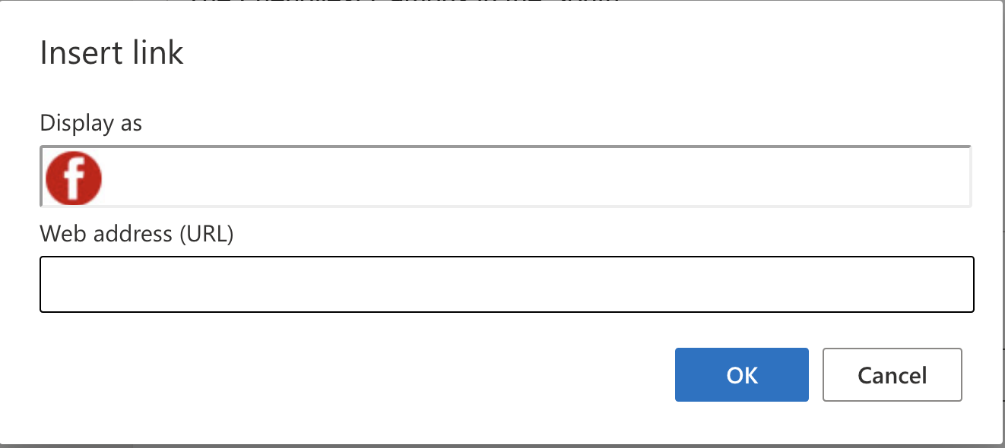

Step 3. Repeat steps 1 & 2 to add additional social media icons with hyperlinks.

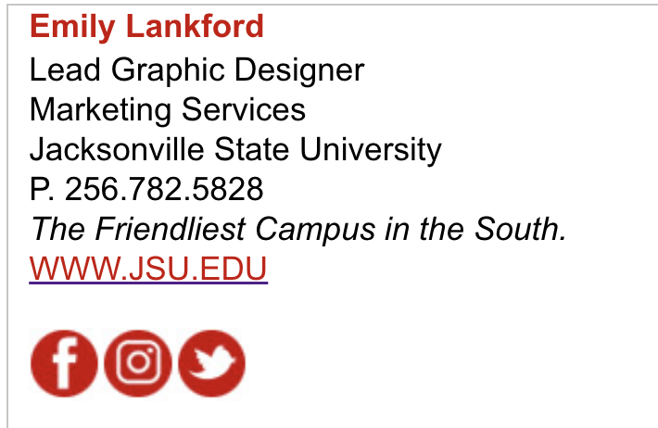

Questions? Feel free to contact us!
Mary Smith, Director of Marketing and Licensing at msmith@jsu.edu | 256.782.5830 or Emily Lankford, Lead Graphic Designer at elankford@jsu.edu | 256.782.5828.

