Click on the VgerSelect icon on the computer desktop (looks like binoculars):

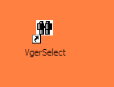

After VgerSelect opens either use an existing Group Definition or click on the button to create a new one.

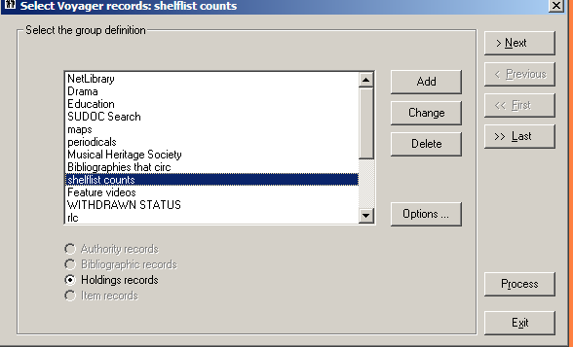

Type in a name for the new Group. “Periodicals” and click 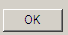

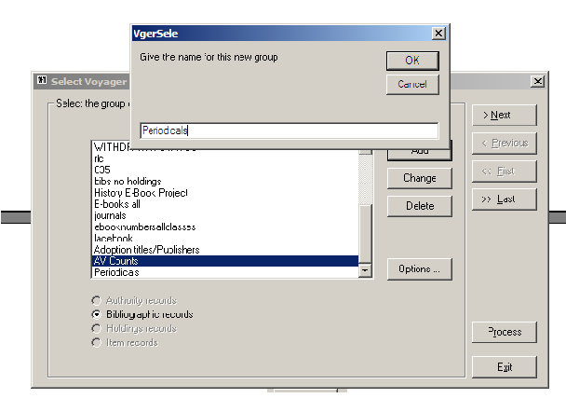

At the next screen click on the radio button for Holdings Records (not bibliographic records) and click the  button to continue.

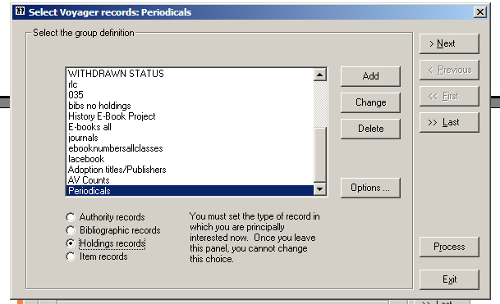
The next screen should be set as follows, and click the button to continue.

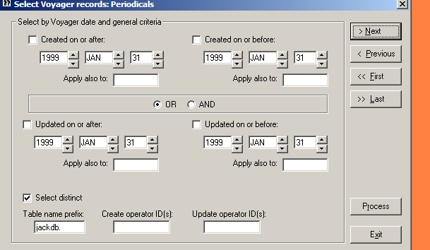

At the next screen enter the call number ranges for the Periodical holdings to be counted 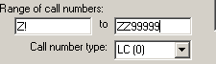 Note: ZZ9999 inclusive range

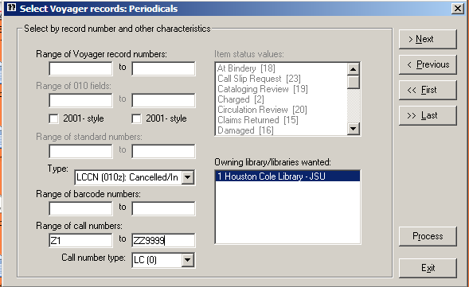
Ignore the next screen and click the button to continue

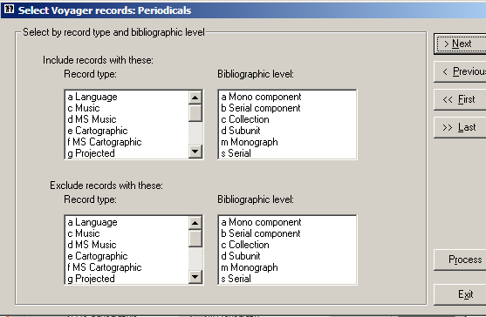

The next screen is where the locations to be counted should be added. Click on the 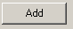 button to retrieve a list of possible locations.

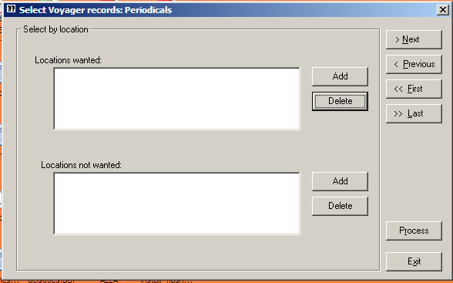

Highlight the desired locations from the list that pops up and click Click the button to continue.

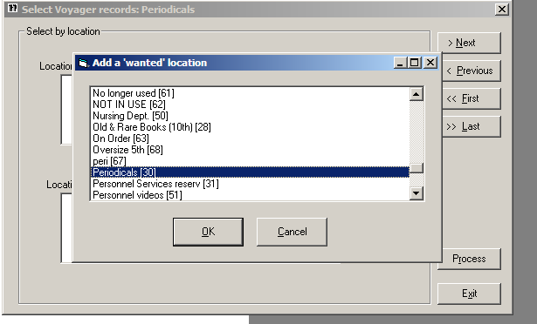

Ignore the next screen and click the button to continue.

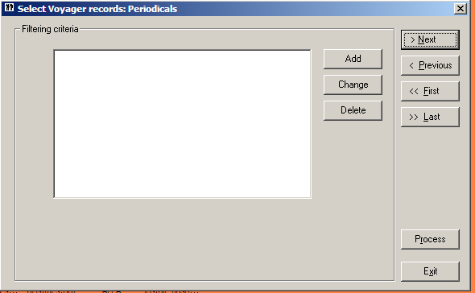

Ignore the next screen and click the button to continue.

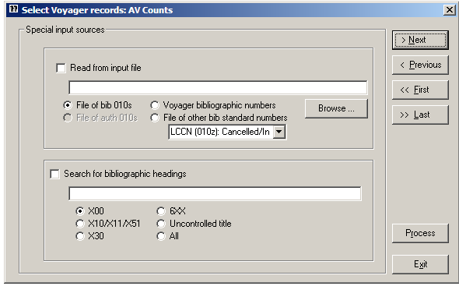.
The next screen is where the format for the output files (what will become a detailed list of the counts) can be customized. Select the checkboxes for Ignore suppressed holdings records and Consider only MFHDS from chosen locations. At this same screen select the checkbox for Selected elements. This will enable the 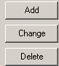 options. Click on the button.

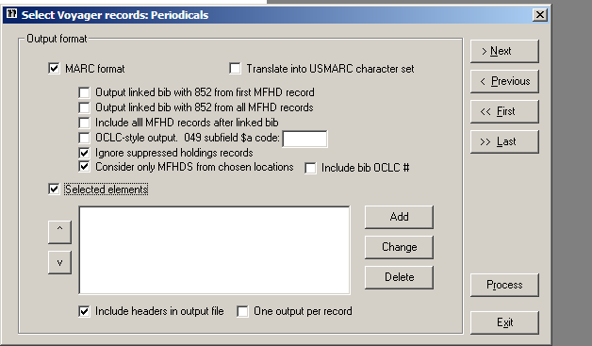

At the next screen label the column Call Number: 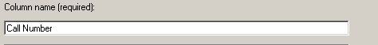
Click the appropriate radio button for the call number from the holdings record and mark that subfield codes be removed.

and

Click

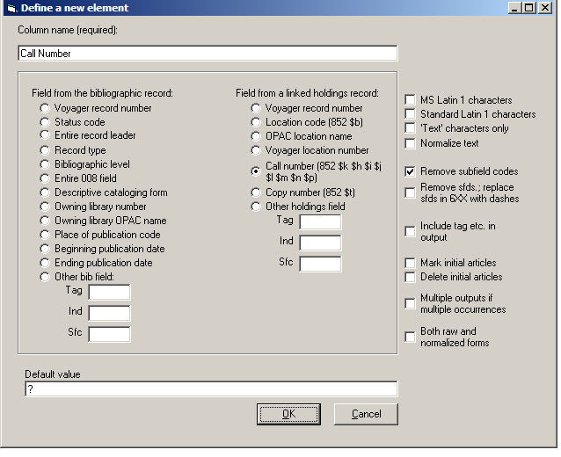

The resulting screen should look as follows:

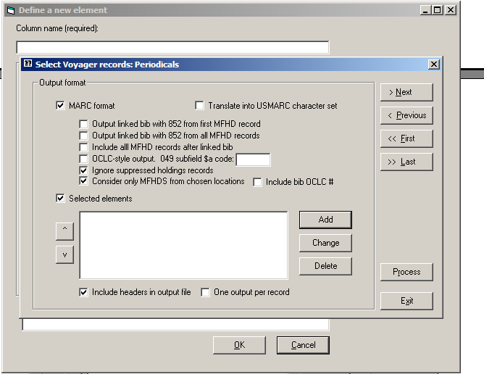

To add an additional element to the report, the Title again, click on the button. At the next screen label the column Title

Select Other bib field: and add 245 to the tag field

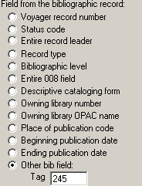 and Click

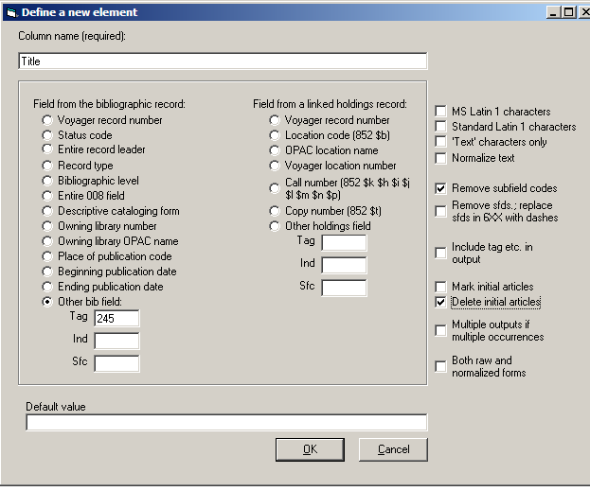
The resulting screen should now have two elements defined for the report:

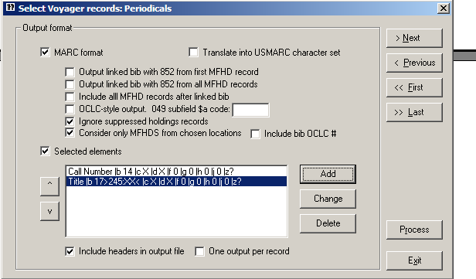

Click on the check box for “Include headers in output file” and click the button.

At the next screen define the name of the file and where the file is to be saved.
It is suggested that to aid in locating the files that they be placed on the Desktop. The path for this directory is C:\Documents and Settings\Library User\Desktop

The Unique File Name radio button is selected and the file named Periodicals 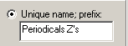
Or, you may opt to use the Generic name.

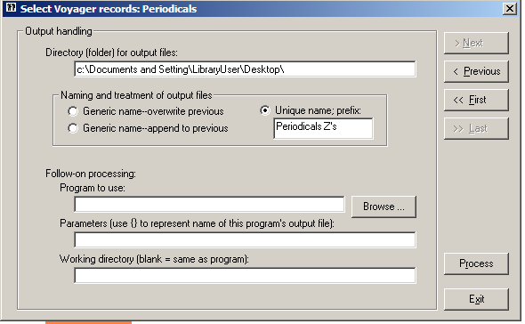

To run the report, click on the 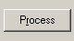 button. The program will count the number of holdings in the Location Periodicals.

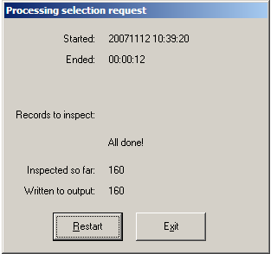

Two text reports will be generated:
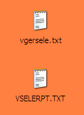

The file with the report.txt suffix is a summary of the actions taken:

***********************************************
* *
* Select Voyager holdings records *
* *
***********************************************

20071112 10:52:39 Job began
20071112 10:52:42 Job ended
00:00:03 Elapsed time for job

20071112 10:52:39 Search (SQL step) began
20071112 10:52:39 Search (SQL step) ended
00:00:00 Elapsed time for search step

20071112 10:52:39 Examination of records began
20071112 10:52:42 Examination of records ended
00:00:03 Elapsed time for examination
0.01875 Average time (seconds) to examine each record
53.3333333333 Records examined per second
3,200.0 Records examined per minute

Initial SQL statement:
SELECT DISTINCT T1.MFHD_ID FROM jackdb.MFHD_MASTER T1 WHERE
(T1.NORMALIZED_CALL_NO BETWEEN 'Z !' AND 'ZZ
9999' AND T1.CALL_NO_TYPE = '0') AND T1.LOCATION_ID = 30

Filtering criteria:
Select by tag/indicator/sfd code alone
OLI/ /

0 records to be read
160 records actually read

160 accepted for inclusion in output file

160 MARC-format records written to output file: c:\vgersele.mrc
160 lines written to output file: c:\vgersele.txt
The second report is the raw data generated by the search. The suffix for the file will be data.txt. Which will open with WordPad.

Call Number Title
Z675.U5 L5 Library-college journal.
Z 673 .A5 B82 American libraries.
Z671 .D7 Drexel library quarterly.
Z671 .J67 The Journal of library history :bJLH.
Z671 .I64 International library review.
Z 671 .A65 The Alabama librarian.
Z673.A5 B8 ALA bulletin.
Z671 .U5 UNESCO bulletin for libraries.
Z732 .A715 Arkansas libraries.
Z1415 .B65 Boletín bibliográfico mexicano.
Z 1035 .A492 The Booklist.
Z1007 .B713 The Bookman.
Z1007 .B717 Books abroad.
Z735.A1 C27 Library journal.
Z 1035 .C5 Choice.
Z881 .W336 The Colby Library quarterly.
Z 5053 .D57 Dissertation abstracts international.nA,pThe humanities and social sciences.
Z 5053 .D57 Dissertation abstracts international.nB,pThe sciences and engineering.
Z1201 .F5 Fichero bibliográfico hispanoamericano.
Z692.M9 F5 Film library quarterly.
Z 1219 .F6 Forthcoming books.
Z119 .G87 Graphic arts monthly and the printing industry.
Z5063.A2 P7 Proceedings in print.
Z1217 .W75 Wilson library bulletin.
Z1007 .S94 Subscription books bulletin.
Z 671 .S72 Special libraries.
Z54 .G81 Today's secretary.
Z671 .S48 Show-me libraries.
Z718.1.A1 T6 Top of the news.
Z678.9.A1 J682 JOLA technical communications.
Z 1219 .B93 Kirkus reviews.
Z673.A5 B8 Bulletin of the American Library Association.
Z 671 .L7154 Library resources & technical services.
Z671 .J67 The Journal of library history.
Z 695.9 .I5 The Indexer :bjournal of the Society of Indexers.
Z 881 .H3403 Harvard Library bulletin.
Z 733 .S241 The Huntington Library quarterly.
Z 732 .I2 I3 Illinois libraries.
Z 671 .L713 The Library quarterly.
Z265 .M565 Microform review.
From here, the WordPad document can be copied into Word and converted to a table. How?

Open the data.txt file click on Edit > Select All > Copy

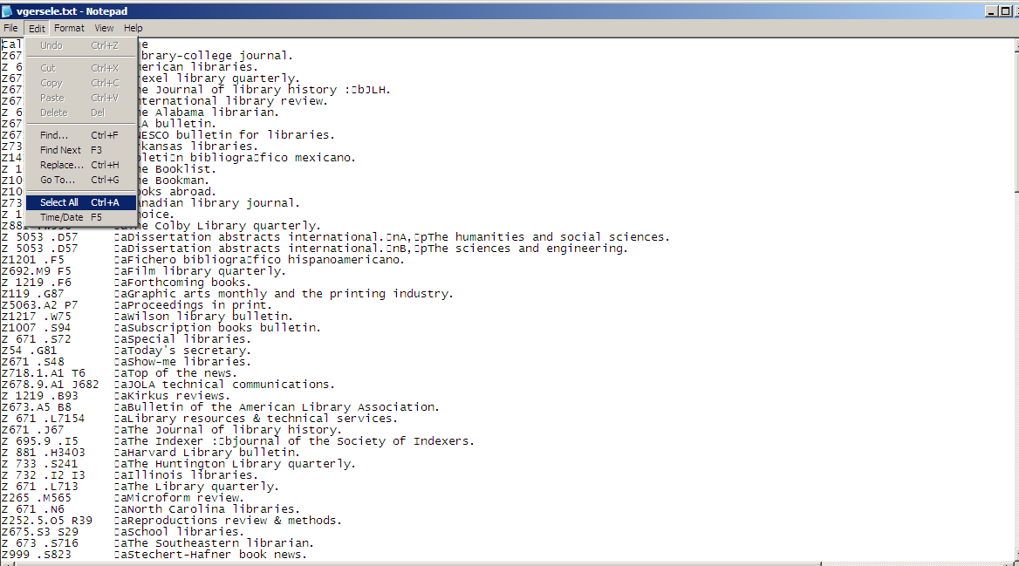

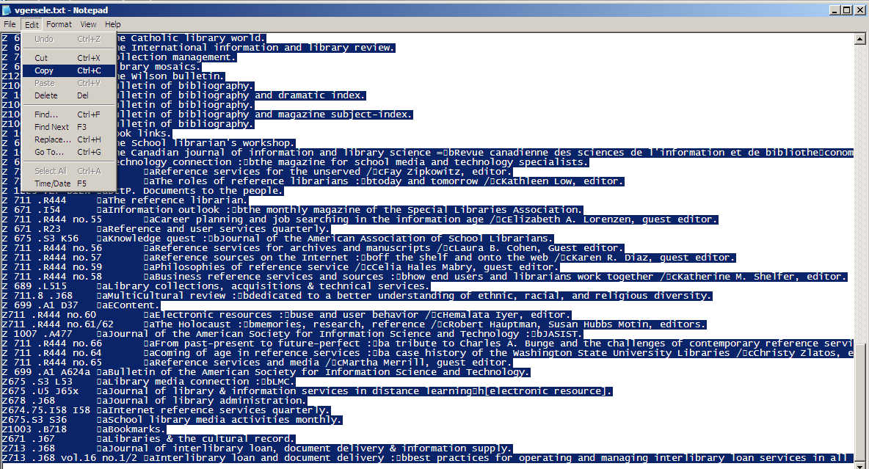
Open a blank document in Microsoft Word and paste the data into Word. The data will be unformatted at this time. See sample below:

Call Number Title
Z 000675.U5 L5 Library-college journal.
Z 000673 .A5 B82 American libraries.
Z 000671 .D7 Drexel library quarterly.
Z 000671 .J67 The Journal of library history : JLH.
Z 000671 .I64 International library review.
Z 000671 .A65 The Alabama librarian.
Z 000673.A5 B8 ALA bulletin.
Z 000671 .U5 UNESCO bulletin for libraries.
Z 000732 .A715 Arkansas libraries.
Z 001415 .B65 Boletín bibliográfico mexicano.
Z 001035 .A492 The Booklist.
Z 001007 .B713 The Bookman.
Z 001007 .B717 Books abroad.
Z 000735.A1 C27 Canadian library journal.
Z 001035 .C5 Choice.
Z 000881 .W336 The Colby Library quarterly.
Z 005053 .D57 Dissertation abstracts international. A, The humanities and social sciences.
Z 005053 .D57 Dissertation abstracts international. B, The sciences and engineering.
Z 001201 .F5 Fichero bibliográfico hispanoamericano.
Z 000692.M9 F5 Film library quarterly.
Z 001219 .F6 Forthcoming books.
Z 000119 .G87 Graphic arts monthly and the printing industry.
Z 005063.A2 P7 Proceedings in print.
Z 001217 .W75 Wilson library bulletin.
Z 001007 .S94 Subscription books bulletin.
Z 000671 .S72 Special libraries.
Z 000054 .G81 Today's secretary.
Z 000671 .S48 Show-me libraries.
Z 000718.1.A1 T6 Top of the news.
Z 000678.9.A1 J682 JOLA technical communications.
Z 001219 .B93 Kirkus reviews.
Z 000673.A5 B8 Bulletin of the American Library Association.
Z 000671 .L7154 Library resources & technical services.
Z 000671 .J67 The Journal of library history.
Z 000695.9 .I5 The Indexer : journal of the Society of Indexers.
Z 000881 .H3403 Harvard Library bulletin.
Z 000733 .S241 The Huntington Library quarterly.
Z 000732 .I2 I3 Illinois libraries.
Z 000671 .L713 The Library quarterly.
To convert the data into a table with columns and headings click on Edit > Select all. After the data is highlighted click on Table > Convert > Text to table:

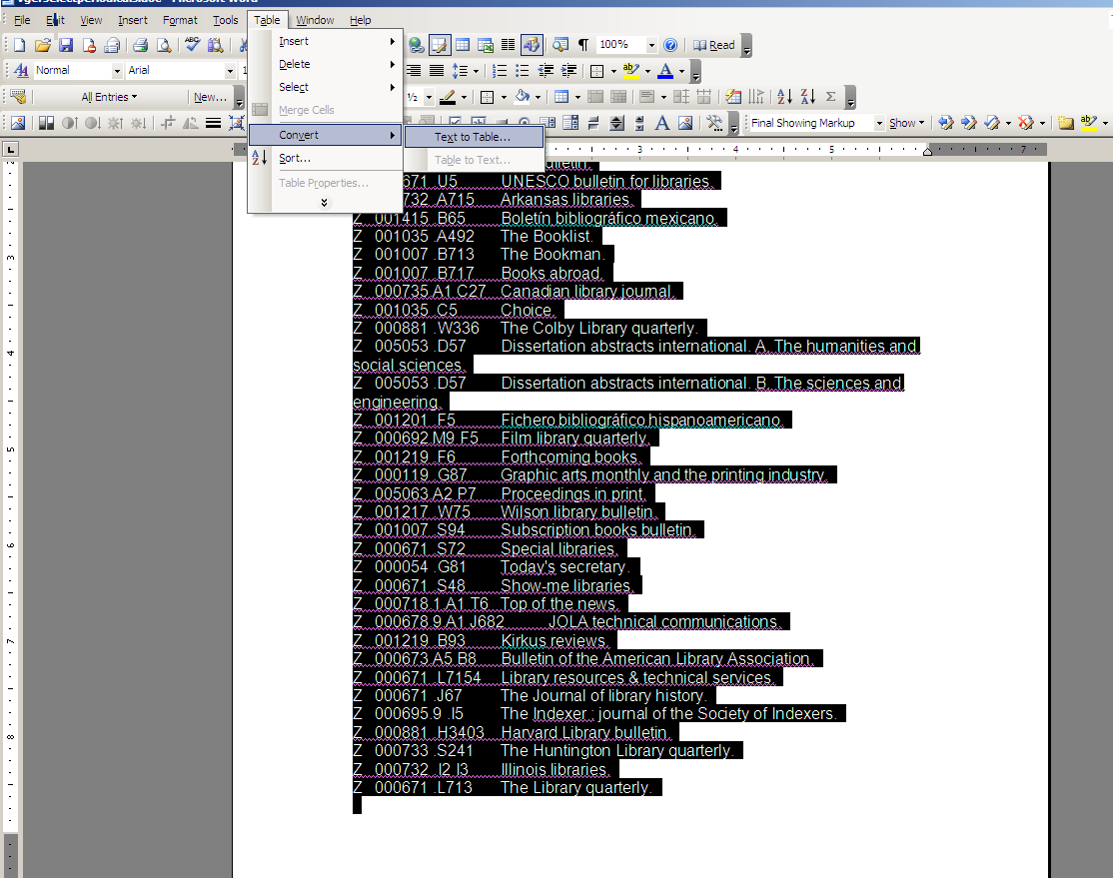

A jump box will appear, please click on the radio button for Tabs under “Separate text as” This will separate the two elements into columns in the table. See table below.

Call Number | Title
Z 000675.U5 L5 | Library-college journal.
Z 000673 .A5 B82 | American libraries.
Z 000671 .D7 | Drexel library quarterly.
Z 000671 .J67 | The Journal of library history : JLH.
Z 000671 .I64 | International library review.
Z 000671 .A65 | The Alabama librarian.
Z 000673.A5 B8 | ALA bulletin.
Z 000671 .U5 | UNESCO bulletin for libraries.
Z 000732 .A715 | Arkansas libraries.
Hint: to get the top row to appear as a heading on each page:

Place the cursor on the top row. Click Table > Table properties. Click on the tab for ROW and click in the check box



